1. PLANNING

Project timeline:

14th – 17th May: Planning, research

18th – 27th May: Project execution, coding

28th – 29th May: Report writing

Milestones:

20nd May: Creation of HTML base website

25th May: Implementation of Javascript methods

27th May: Adding of CSS, animations, website favicon, background

1. TECHNICAL

Technologies used: HTML, CSS, Javascript.

Usage of HTML and CSS to create website, text animation, styling, and UI for website icon and background.

Code snippet of animated text.

Usage of Javascript to generate alphabet buttons, implement onclick and reset buttons, and to change hangman image after each guess accordingly using number of guesses. Additionally, displaying different messages depending on whether player won or lost the game.

1. PROJECT DOCS

**IPHONE SE**

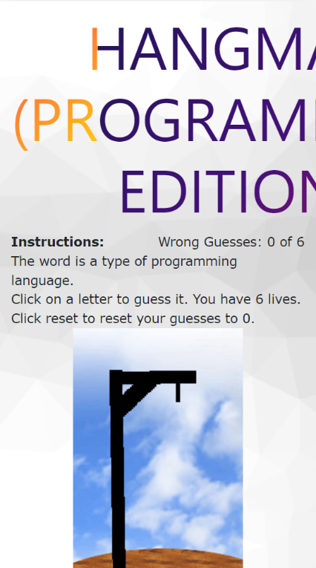 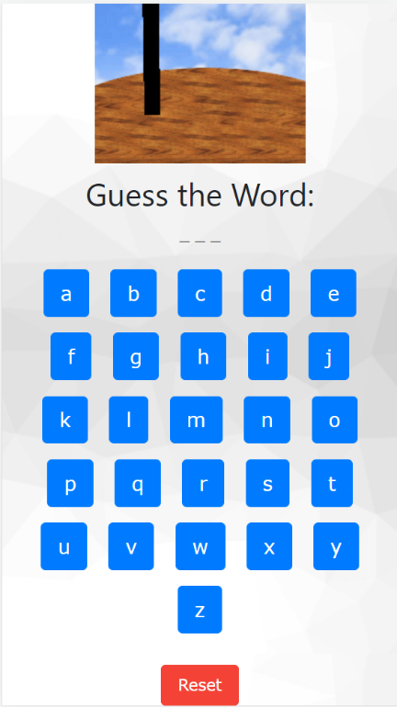 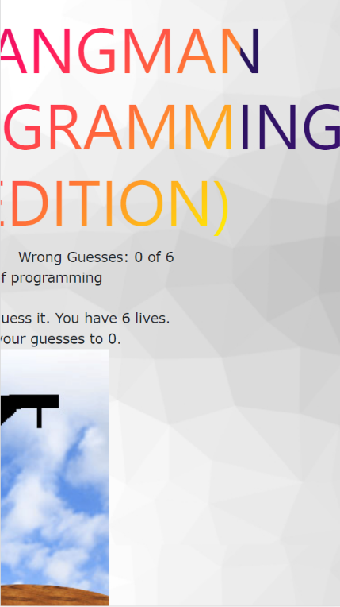

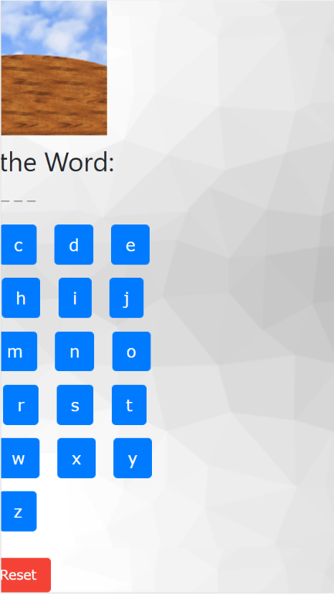 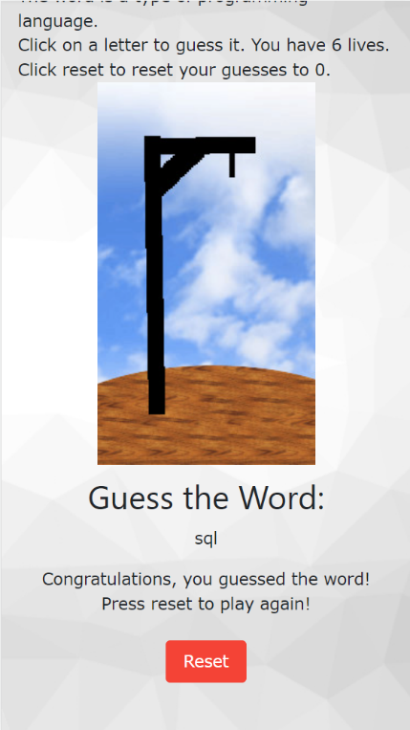

**IPAD**

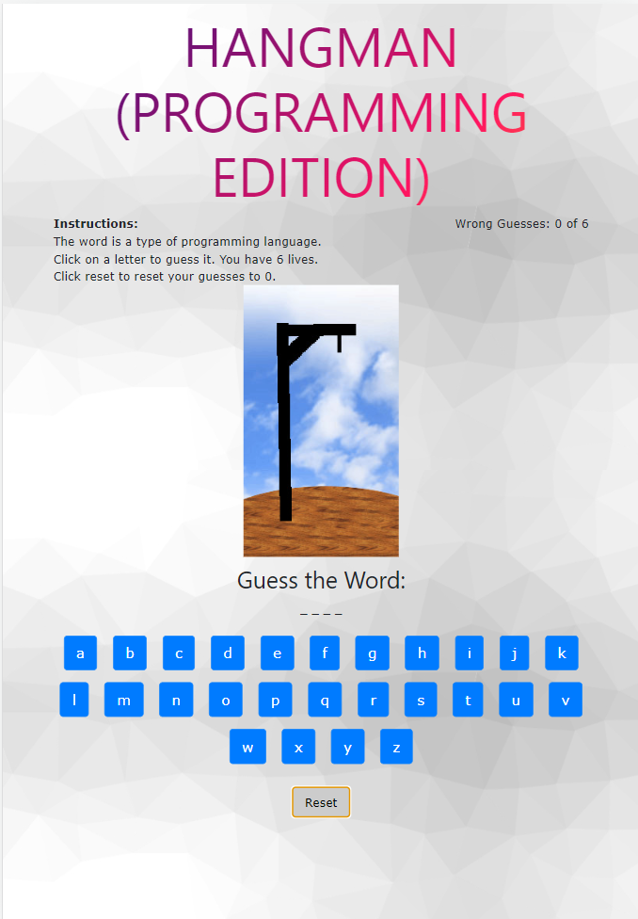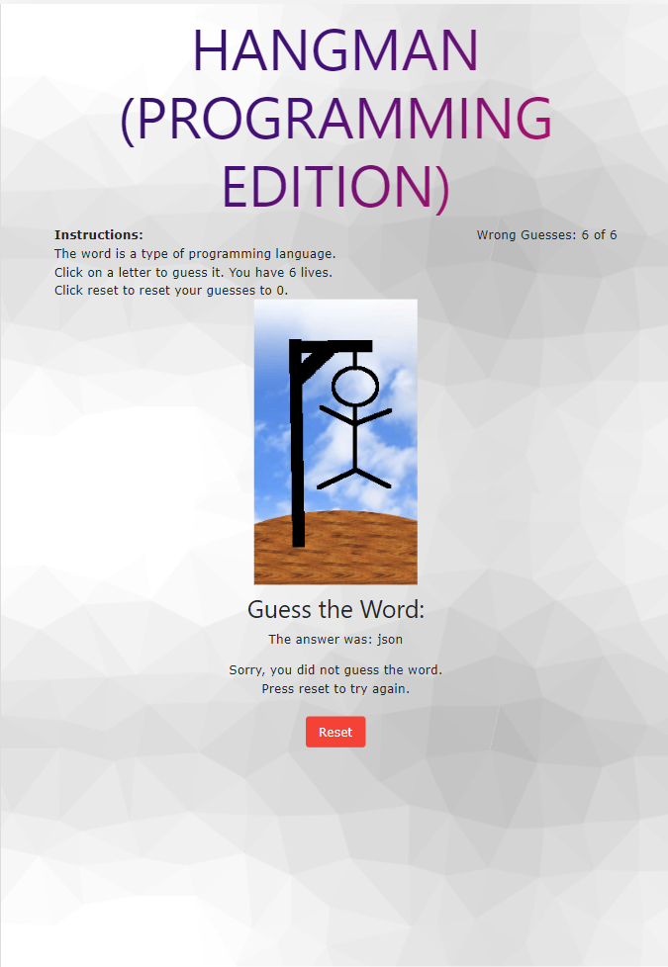

**LAPTOP**

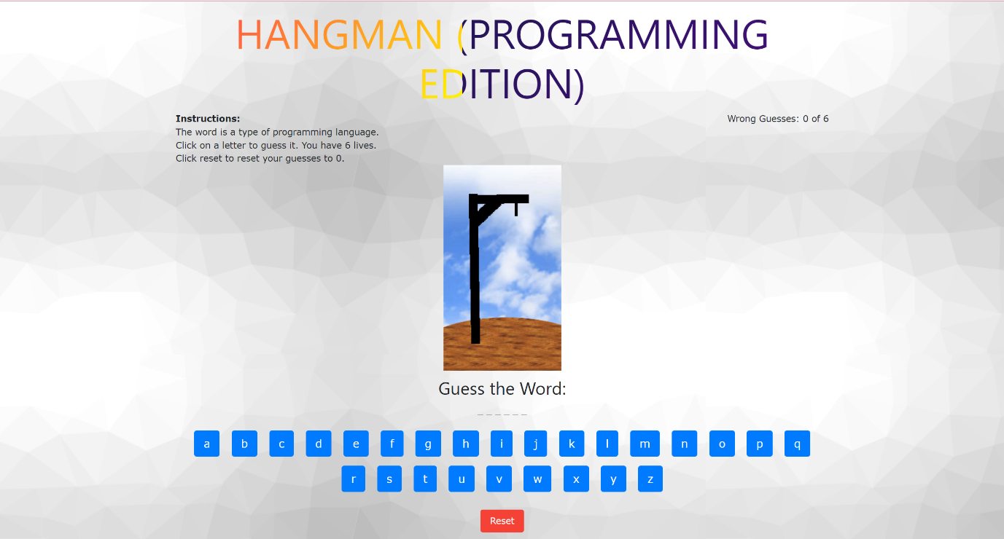

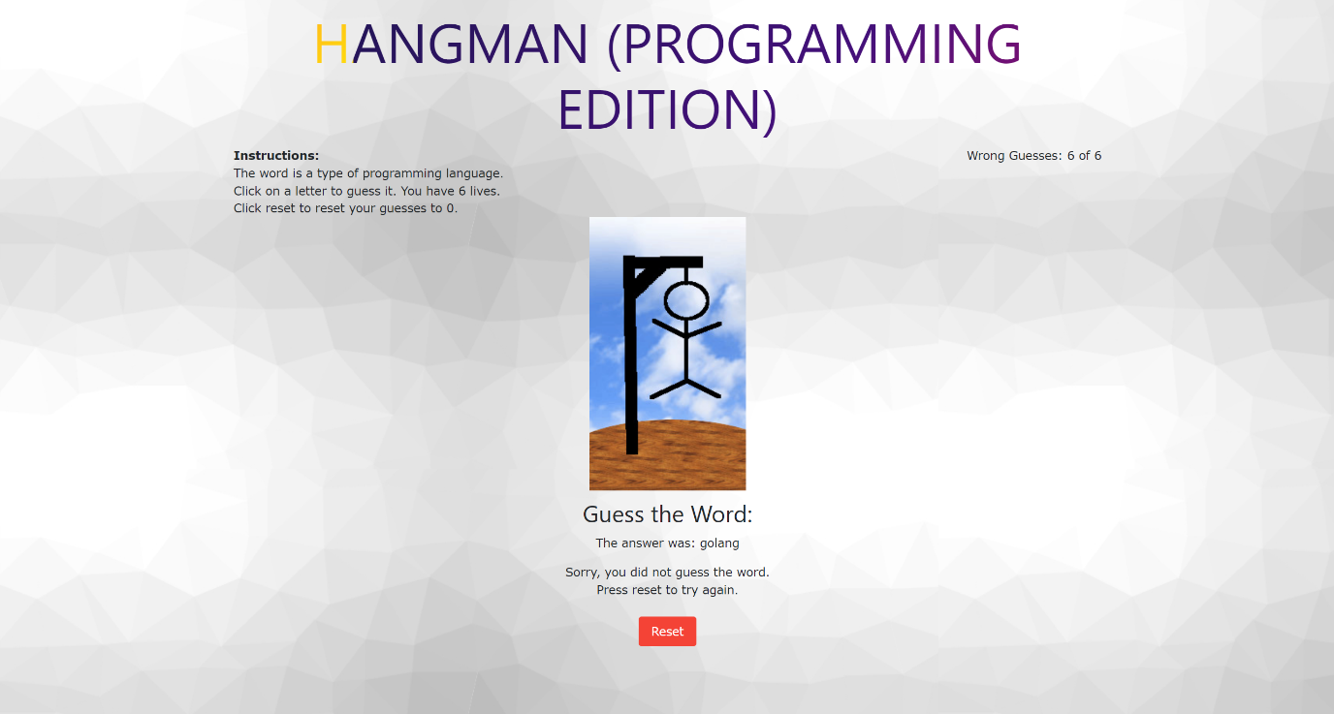

1. PROJECT RETROSPECTIVE

**What went well:**

Able to create a hangman web application as per requirements, using HTML, Javascript and CSS.

Able to display different images according to number of wrong guesses.

Website can be displayed and is responsive on laptop, mobile and tablet.

**What could be improved:**

Website’s UI could be improved, perhaps adding animation when changing images between number of wrong tries.

Due to the animated text header being too big, the alignment is not straight on iPhone SE.

Instead of reusing Reset button, could display different coloured buttons depending on whether in game, won or loss screen.

Was unable to use React for this project due to lack of understanding and knowledge, could do more research on React and see how it can be used to further enhance the website.